Design of Cyclic Code Encoder and Decoder Using Polynomial Arithmetic in MATLAB
1. Aim
To design a Cyclic Code encoder and decoder using polynomial arithmetic in MATLAB and verify the generated codeword.

2. Theory
A cyclic code is a linear block code in which any cyclic shift of a valid codeword is also a valid codeword.
Let:
- Message polynomial = $m\left(x\right)$
- Generator polynomial = $g\left(x\right)$
- Codeword polynomial = $c\left(x\right)$
- Code length = $n$
- Message length = $k$
- Number of parity bits = $r=n-k$
The codeword is generated using:
$$c\left(x\right)=m\left(x\right)x^{r}+p\left(x\right)$$
where $p\left(x\right)$is the remainder obtained by dividing $m\left(x\right)x^{r}$by $g\left(x\right)$.
Thus,
$$p\left(x\right)=\operatorname{rem}\left[m , \left(x\right)x^{r}g\left(x\right)\right]$$
and
$$c\left(x\right)=m\left(x\right)x^{r}+p\left(x\right)$$
All polynomial operations are performed using modulo-2 arithmetic, where:
$$1+1=0$$

3. Encoder
Encoding steps
- Select the message bits.
- Select a generator polynomial $g\left(x\right)$.
- Calculate $r=n-k$.
- Multiply the message polynomial by $x^{r}$.
- Divide the resulting polynomial by $g\left(x\right)$.
- Find the remainder $p\left(x\right)$.
- Add the remainder to obtain the codeword.
Example
Consider:
$$m=\left[1 0 1 1\right]$$
and generator:
$$g\left(x\right)=x^{3}+x+1$$
Therefore:
$$g=\left[1 0 1 1\right]$$
Here,
$$k=4, r=3, n=7$$
The message is multiplied by $x^{3}$:
$$m\left(x\right)x^{3}$$
Then divide by $g\left(x\right)$using modulo-2 polynomial division.
The resulting codeword is:
$$\boxed{c=\left[1 0 1 1 0 0 1\right]}$$

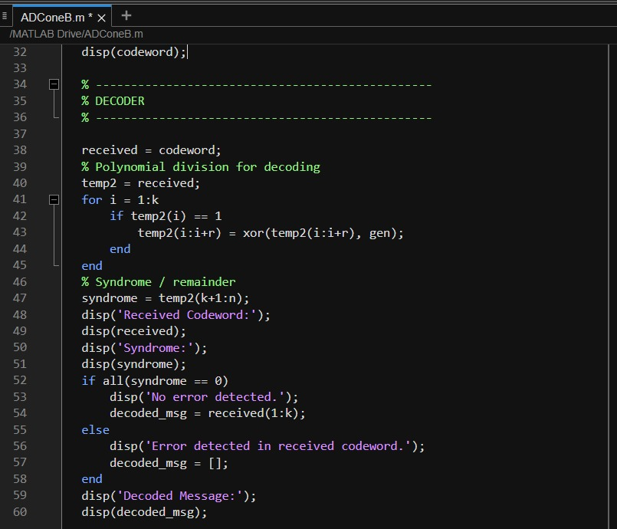
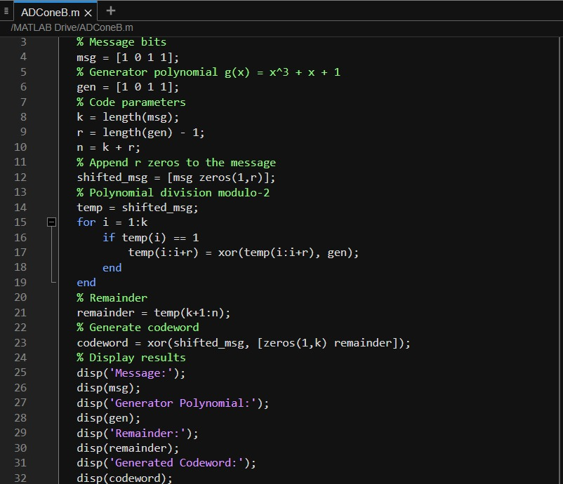
4. MATLAB Program:

Output:
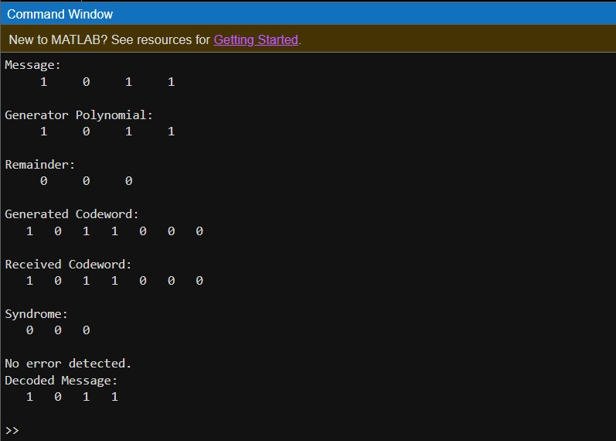
Cyclic Code Decoder
At the receiver, the received codeword is divided by the same generator polynomial.
Let the received polynomial be:
$$r\left(x\right)$$
Calculate:
$$S\left(x\right)=r\left(x\right) mod g\left(x\right)$$
where $S\left(x\right)$is called the syndrome.
Decision
- If syndrome = 000, there is no detectable error.
- If syndrome ≠ 000, an error is detected.
For the transmitted codeword:
$$1011001$$
division by $g\left(x\right)$gives:
$$S\left(x\right)=000$$
Therefore, the received codeword is valid.
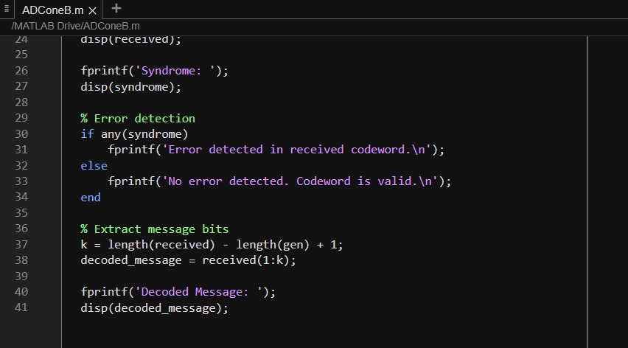
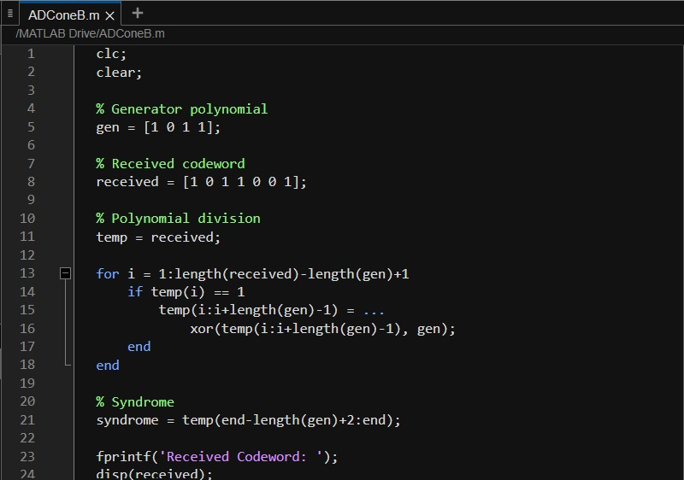
6. MATLAB Decoder Program

Output:
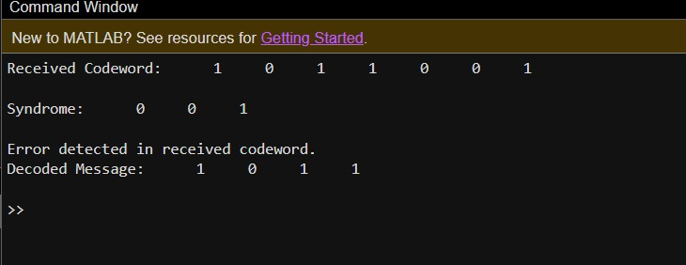

7. Verification of Codeword
For the selected message:
$$m=1011$$
Generator:
$$g\left(x\right)=x^{3}+x+1$$
The encoder produces:
$$\boxed{c=1011001}$$
Now,
$$1011001÷1011$$
gives:
$$\boxed{\text{Remainder}=000}$$
Therefore, the generated codeword satisfies the cyclic-code condition.
$$\boxed{c\left(x\right) mod g\left(x\right)=0}$$
Hence, the codeword generation and decoding are successfully verifie
9. Result
Thus, a Cyclic Code encoder and decoder were successfully designed using polynomial arithmetic in MATLAB. For the message 1011 and generator polynomial $g\left(x\right)=x^{3}+x+1$, the generated codeword is 1011001. The zero syndrome verifies that the codeword is valid.

